README

INSTALLATION AND SETUP

PYGObject for Windows download link: https://sourceforge.net/projects/pygobjectwin32/

Download and install just like any other non-Webkit, normal, user-friendly, no bs program.

Dependencies:
Python 3.0-3.4 (newest version is 3.5 but won't work) https://www.python.org/downloads/windows/

Once you have downloaded it, drag it to your Desktop for easy access. The Icon should look like this:
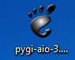

When you double-click on it you should get this:
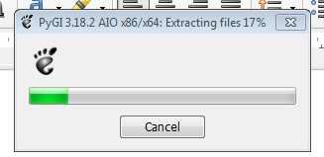

When it finishes extracting files you will get this other dialog box:
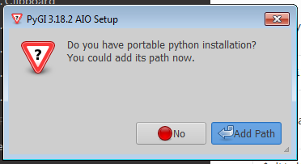

Click on NO.

Then you will get this window:

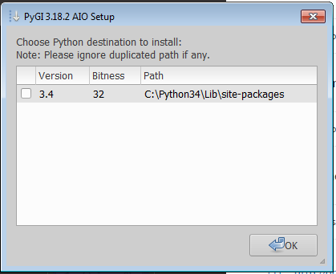

If you have more than one version of Python, they will appear here. Choose 3.X and click OK.

This will open the setup dialog box. Here you will choose which libraries to install.

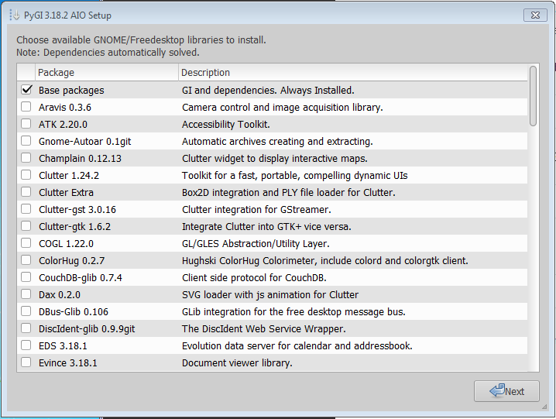

Look at the libraries and see if you think any of those would be helpful for our project, but at the very least from the first selection, select these:

- JSON-glib 1.0.4 (maybe will come in handy)
- Glib-Controller 0.1.1git (for the JSON one, also may be helpful)
- GTK+ 3.18.9 (necessary
- WebkitGTK 2.2.8 (necessary)
- Webkit2GTK 2.2.8 (just in case)

Click NEXT.
You will get another list of libraries.
From this one select:

- Log4g 0.1.2 (may come in handy?)
- Mongo-glib 0.3.2

Click NEXT.

You will get another dialog box with a much shorter list of libraries.
Select this one:

- Glade 3.18

Click NEXT.

You will get a dialog box asking “Ready to install?”.
Click YES.

You will get a progress bar and a few Terminal windows will open and it will seem like you're in the Matrix or you are being hacked. You're not. Maybe, I don't know.

When everything finishes you will get this window:
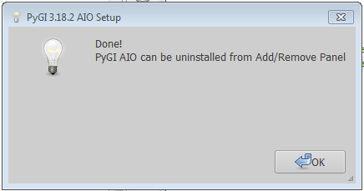

TESTING

To verify the Gtk and Webkit were installed properly, run this Python script:

import gi
gi.require_version("Gtk","3.0")
gi.require_version("WebKit","3.0")
from gi.repository import Gtk
from gi.repository import WebKit
view=WebKit.WebView()

sw=Gtk.ScrolledWindow()
sw.add(view)

win= Gtk.Window()
win.add(sw)
win.show_all()

view.open("http://visjs.org/examples/timeline/basicUsage.html")
win.connect("delete-event", Gtk.main_quit)
Gtk.main()

You can run it line by line on the command prompt or create a file with Notepad or any text editor and run it using the terminal. The command will be a variation of the following depending on where you have your files saved:

You should get a window that looks like this:

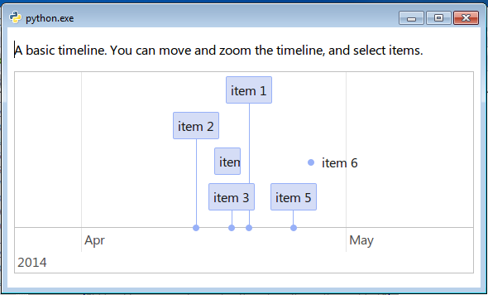

If you have any questions or found libraries that you feel would be helpful and I didn't include them here, let me know.

